Buatlah Database dengan nama: penjualan.mdb
Buatlah tabel-tabel berikut:
Table: barang
Field | Type | Size | Ket
kd_brg | Text | 5 | Primary + Unique
nama | Text | 30 | -
harga | Currency | - | -
satuan | Text | 10 | -
stok | Integer | - | -

Isi beberapa record :
kd_brg | nama | harga | satuan | stok
BR001 | BUKU | 3500 | PCS | 30
BR002 | PENSIL | 24000 | LUSIN | 10
BR003 | PENGHAPUS | 10000 | LUSIN | 12

Table: transaksi
Field | Type | Size | Ket
Nonota | Text | 10 | Primary + Unique
Tanggal | Date / Time | - | -
Kd_brg | Text | 5 | -
Nama | Text | 30 | -
Harga | Currency | - | -
Subtotal | Currency | - | -
Diskon | Currency | - | -
Ubayar | Currency | - | -
Ukembali | Currency | - | -
Jumbel | Integer | - | -

Buat desain seperti berikut:
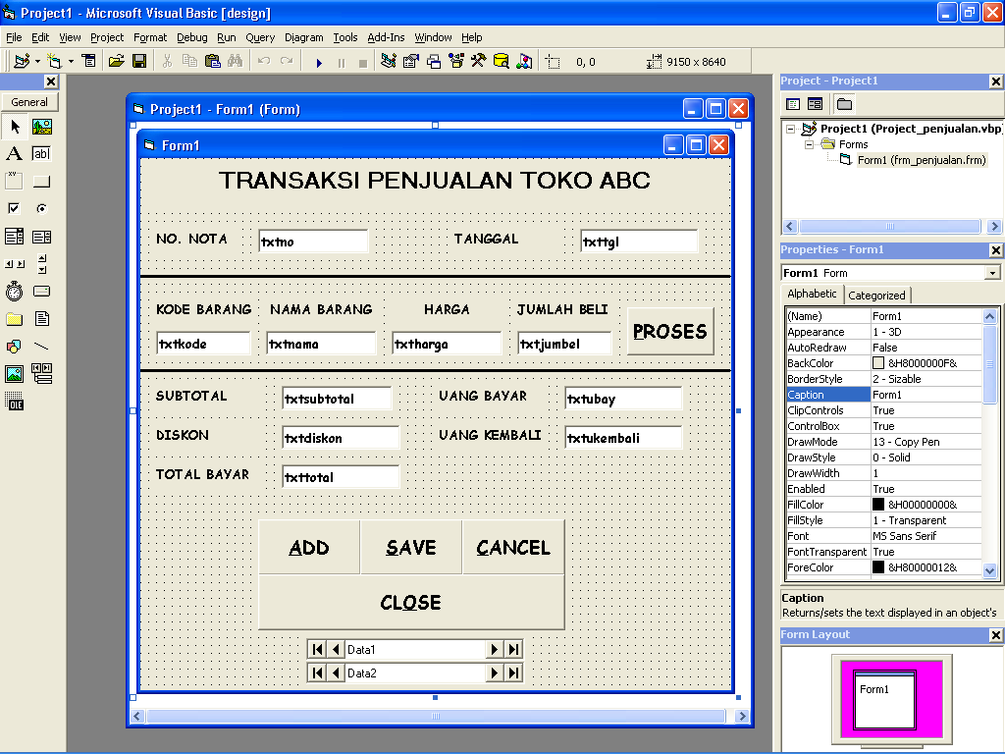

Ketentuan soal:
- Ketika form dijalankan, semua textbox dalam keadaan tidak aktif.
- Klik Add maka textbox aktif dan bersih, kursor berada di No. Nota.
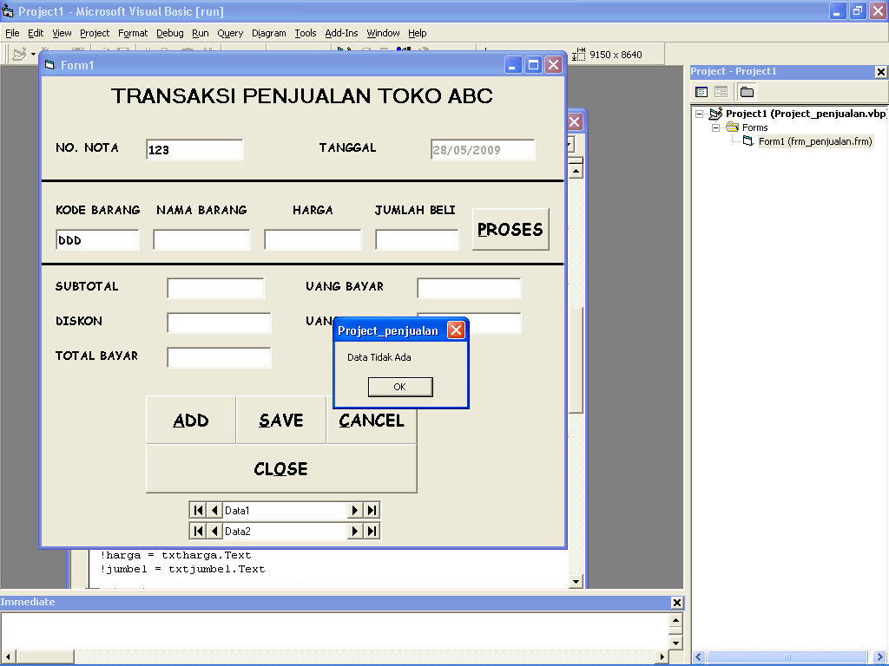
- Input kode barang kemudian tekan Enter, jika kode barang ditemukan maka akan tampil nama barang dan harga. Jika tidak, maka tampil pesan

- Klik Proses maka tampil subtotal, diskon dan total bayar.
  - Subtotal = hitung sendiri…!!!
  - Jika jumlah beli > 10 maka Diskon = 0.1 * Subtotal, selain itu Diskon = 0
  - Total Bayar = hitung sendiri…!!
- Input uang bayar, maka tampil uang kembali.
- Klik Save maka program akan menyimpan data dan semua textbox tidak aktif.
- Klik Cancel maka semua textbox tidak aktif.
- Klik Close maka program akan menutup.

Listing selengkapnya:

Sub bersih()
Sub aktif()
txtno.Enabled = True
txtkode.Enabled = True
txtjumbel.Enabled = True
txtubay.Enabled = True
End Sub

Private Sub cmdadd_Click()
Call aktif
Call bersih
txtno.SetFocus
End Sub

Private Sub cmdcancel_Click()
bersih
nonaktif
End Sub

Private Sub cmdclose_Click()
End
End Sub
txtno.Text = " "
txtkode.Text = " "
txtnama.Text = " "
txtharga.Text = " "
txtjumbel.Text = " "
txtsubtotal.Text = " "
txtdiskon.Text = " "
txttotal.Text = " "
txtubay.Text = " "
txtukembali.Text = " "
End Sub

Sub nonaktif()
txtno.Enabled = False
txttgl.Enabled = False
txtkode.Enabled = False
txtnama.Enabled = False
txtharga.Enabled = False
txtjumbel.Enabled = False
txtsubtotal.Enabled = False
txtdiskon.Enabled = False
txttotal.Enabled = False
txtubay.Enabled = False
txtukembali.Enabled = False
End Sub
Private Sub cmdproses_Click()
txtsubtotal.Text = Val(txtharga.Text) * Val(txtjumbel.Text)
If txtjumbel.Text > 10 Then
txtdiskon.Text = Val(txtsubtotal.Text) * 0.1
Else
txtdiskon.Text = 0
End If
txttotal.Text = Val(txtsubtotal.Text) - Val(txtdiskon.Text)
txtubay.SetFocus
End Sub

Private Sub cmdsave_Click()
With Data2.Recordset
.AddNew
!nonota = txtno.Text
!tanggal = txttgl.Text
!kd_brg = txtkode.Text
!nama = txtnama.Text
!harga = txtharga.Text
!jumbel = txtjumbel.Text
!subtotal = txtsubtotal.Text
!diskon = txtdiskon.Text
!total = txttotal.Text
!ubayar = txtubay.Text
!ukembali = txtukembali.Text
.Update
End With
Form_Activate
End Sub

Private Sub Form_Activate()
bersih
nonaktif
txttgl.Text = Date
End Sub

Private Sub txtkode_KeyPress(KeyAscii As Integer)
KeyAscii = Asc(UCase(Chr(KeyAscii)))
If KeyAscii = 13 Then
Data1.Recordset.FindFirst "kd_brg= ' " & txtkode.Text & " ' "
If Not Data1.Recordset.NoMatch Then
txtnama.Text = Data1.Recordset!nama
txtharga.Text = Data1.Recordset!harga
txtjumbel.SetFocus
Else
MsgBox "Data Tidak Ada"
txtkode.Text = " "
txtkode.SetFocus
End If
End If
End Sub

Private Sub txtno_KeyPress(KeyAscii As Integer)
If KeyAscii = 13 Then
txtkode.SetFocus
End If
End Sub

Private Sub txtubay_Change()
txtukembali.Text = Val(txtubay.Text) - Val(txttotal.Text)
End Sub

Buatlah Database dengan nama: akademik.mdb
Buatlah tabel-tabel berikut:
Table: mahasiswa
Field | Type | Size | Ket
kd_matkul | Text | 3 | Primary + Unique
nm_matkul | Text | 30 | -

Isi record berikut:
Kd_matkul | Nm_matkul
318 | PPN I
544 | DESAIN GRAFIS
734 | VISUAL BASIC

Table: nilai
Field | Type | Size | Ket
nim | Text | 8 | Buat index, hilangkan checklist pd Primary & Unique
nama | Text | 50
kd_matkul | Text | 3 | Buat index, hilangkan checklist pd Primary & Unique
nm_matkul | Text | 30
n_absen | Integer | -
n_tugas | Integer | -
n_uts | Integer | -
n_uas | Integer | -
n_akhir | Integer | -
grade | Text | 1

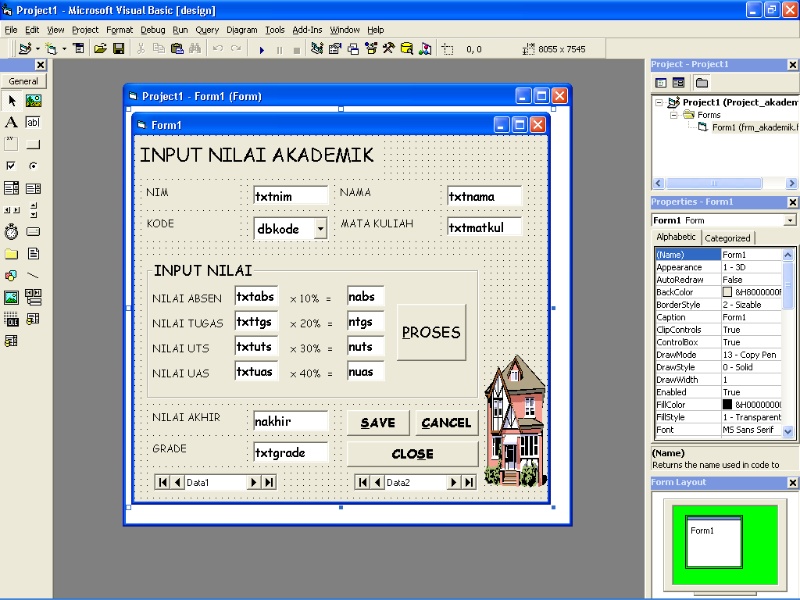
Buat desain seperti berikut!!
Ketentuan soal:
- Pada saat form diaktifkan, semua textbox dalam keadaan bersih. Kursor berada di NIM.
- Pilih Kode maka tampil Nama Mata Kuliah.
- Klik Proses maka tampil Nilai akhir dan Grade.
Jika Nilai Akhir > 80 maka Grade = A
Jika Nilai Akhir > 50 maka Grade = B
Selain itu Grade = C
- Tombol Save untuk menyimpan data.
- Tombol Cancel untuk membatalkan.

Listing selengkapnya:

Sub bersih()
Sub nonaktif()
txtmatkul.Enabled = False
nabs.Enabled = False
ntgs.Enabled = False
nuts.Enabled = False
nuas.Enabled = False
nakhir.Enabled = False
txtgrade.Enabled = False
End Sub

Private Sub Form_Activate()
bersih
nonaktif
txtnim.SetFocus
End Sub

txtnim.Text = ""
dbkode.Text = ">>Pilih<<"
txtnama.Text = ""
txtmatkul.Text = ""
txtabs.Text = ""
txttgs.Text = ""
txtuts.Text = ""
txtuas.Text = ""
nabs.Text = ""
ntgs.Text = ""
nuts.Text = ""
nuas.Text = ""
nakhir.Text = ""
txtgrade.Text = ""
End Sub

Private Sub cmdcancel_Click()
Form_Activate
End Sub

Private Sub cmdproses_Click()
nakhir = Val(nabs.Text) + Val(ntgs.Text) + Val(nuts.Text) + Val(nuas.Text)
If nakhir.Text > 80 Then
txtgrade.Text = "A"
ElseIf nakhir.Text > 50 Then
txtgrade.Text = "B"
Else
txtgrade.Text = "C"
End If
cmdsave.SetFocus
End Sub

Private Sub cmdsave_Click()
With Data2.Recordset
.AddNew
!nim = txtnim.Text
!nama = txtnama.Text
!kd_matkul = dbkode.Text
!nm_matkul = txtnama.Text
!n_absen = nabs.Text
!n_tugas = ntgs.Text
!n_uts = txtuts.Text
!n_uas = txtuas.Text
!n_akhir = nakhir.Text
!grade = txtgrade.Text
.Update
End With
bersih
txtnim.SetFocus
End Sub

Private Sub dbkode_Change()
Data1.Recordset.FindFirst "kd_matkul= ' " & dbkode.Text & " ' "
If Not Data1.Recordset.NoMatch Then
txtmatkul.Text = Data1.Recordset!nm_matkul
End If
txtabs.SetFocus
End Sub

Private Sub txtabs_KeyPress(KeyAscii As Integer)
If KeyAscii = 13 Then
nabs.Text = 0.1 * Val(txtabs.Text)
txttgs.SetFocus
End If
End Sub

Private Sub txttgs_KeyPress(KeyAscii As Integer)
If KeyAscii = 13 Then
ntgs.Text = 0.2 * Val(txttgs.Text)
txtuts.SetFocus
End If
End Sub

Private Sub txtuas_KeyPress(KeyAscii As Integer)
If KeyAscii = 13 Then
nuas.Text = 0.4 * Val(txtuas.Text)
cmdproses.SetFocus
End If
End Sub

Private Sub txtuts_KeyPress(KeyAscii As Integer)
If KeyAscii = 13 Then
nuts.Text = 0.3 * Val(txtuts.Text)
txtuas.SetFocus
End If
End Sub

